# Week 2

## Lecture 2: Why Experimentation

Experiments are the best way to know whether a program actually works

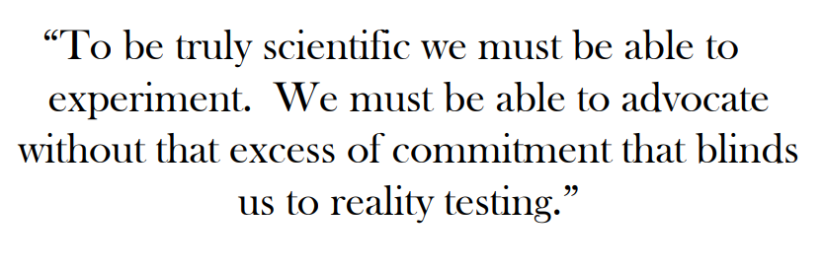

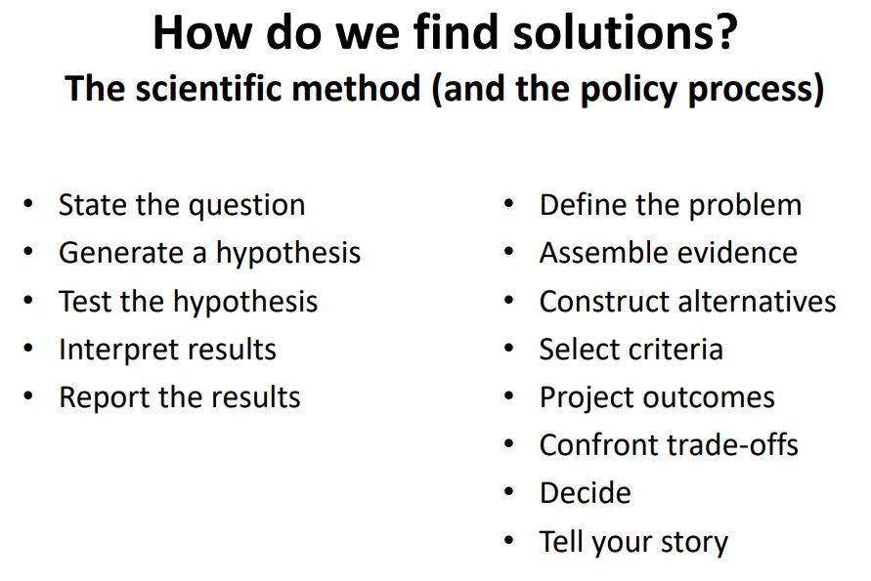

**The Culture Cycle**

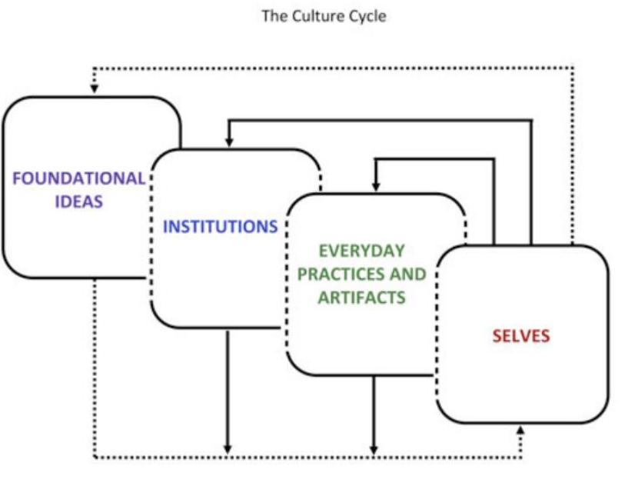

**Socioecological Model**

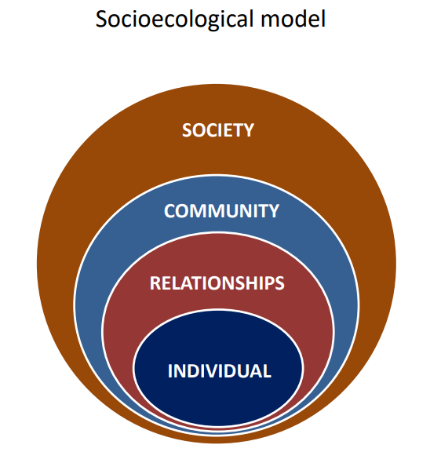

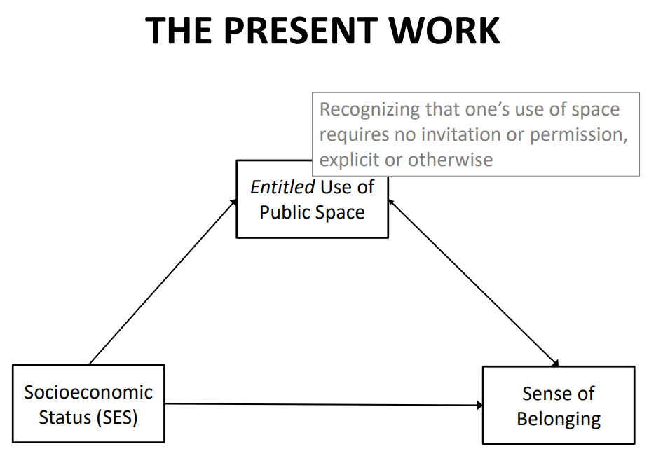

*Iconic spaces:* public spaces that are symbolic of group identity, that are widely recognized as representing a group’s identity, its attributes, values, and history

Disadvantages of correlations are the directionality problem and the third variable problem

Establishing causation:

1. Relationship between cause and effect (correlation)
2. Temporal precedence (rule out reverse causation)
3. No alternative explanation (rule out 3rd vars)

## Week 2 Readings

**The Partisan Brain: An Identity-Based Model of Political Belief**

* Democracies don’t actually have knowledgeable citizens
* People engage in motivated political reasoning but partisanship can alter memory, implicit evaluation, and even perceptual judgements
* *Partisanship:* identification with a political party
* Influence of partisanship affects the democratic process, public debate, and the ability to make informed choices
* Parties tend to reflect people’s ideologies, ideology and identity are often closely aligned but not always
* *Social identity theory:* people can define themselves according to who they are as individuals as well as their membership in various social groups
* *Evolutionary theory:* argues that brain evolved to detect coalitional alliances
* Basic needs like belonging, distinctiveness, epistemic closure, and access to power and resources
* Cognitive dissonance is aversive, it’s when different beliefs are in conflict with one another
* 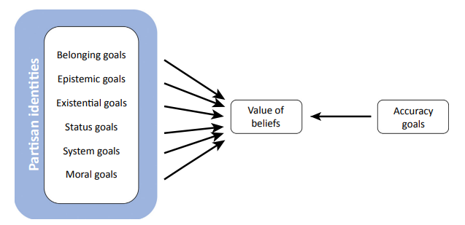
* Partisan identities alter political judgment and behavior
* Orbitofrontal cortex (OFC) may be responsible for computing the value of competing goals
* Parties can act as heuristics (social identities)
* People have an implicit bias towards policies held by their in-group policy member
* Interventions that either fulfill social needs through nonpartisan means or motivate people to search for the truth, thereby increasing the strength of accuracy goals, will reduce partisan bias
* Professional training and guidelines for evaluating evidence fairly can reduce the effect of personal values
* Correcting misinformation is often ineffective

## Lecture 3

*What does a rational voter look like?*

Emotions don’t need to be thought of as the opposite of reasoned thinking

**Social contract theory:** people come together to create a state and govern themselves through rational choice (because it is in our best interest to do so)

**Rational choice theory:** people have stable preferences, preferences guide behavior (people maximize benefits and minimize costs)

* Assume that people are self-interested
* *Corollary 1:* people are able and willing to process and analyze available and relevant information to maximize benefits and minimize costs
* *Corollary 2:* if we think they are choosing bad or wrong, we just need to give them more information
* *Corollary 3:* If we think people’s preferences are bad or wrong, we can just force them to change their choices

A model of rational voting:

* Come to an election and think about differentiating issues
* Is this issue relevant to myself or my group? Give things appropriate weights.
* Which candidate has more utility for me?
* Get weighted average and decide on a candidate

You need a lot of info to vote based on cost and benefits

There are a lot of gaps in people’s governance knowledge

Is the answer more information?

* Motivated cognition, confirmation bias, cognitive dissonance
* Ideology undermines our ability to see the logic of arguments we initially disagree with
* Likelihood of correct assessment of logical soundness is correlated with whether or not the statements align with our political ideology

Where rationality falls apart:

* Framing, explicit vs. implicit attitudes
* Attitude-behavior link, social norms, won’t be self-interested at the cost of moral values
* Lack of knowledge, motivated cognition
* The paradox of choice (paralysis and lower satisfaction), the complex relationship between info and ideology

# Week 4

## Week 4 Readings

**Intergroup Contact Theory**

* How can we reduce prejudice and intergroup conflict?
* Social scientists started proposing intergroup contact in the 1930s
* intergroup contact not always reduces prejudice; on the contrary, it sometimes even might strengthen stereotypical views of outgroups and increases negative sentiments
* hypothesis is that intergroup contact only reduces prejudice in situations that meet 4 optimal conditions: equal group status within the contact situation, common goals, intergroup cooperation, and support of authorities, law, or custom
* effect of intergroup contact was larger in samples where contact was structured to meet Allport’s optimal contact conditions
* one cannot exclude the possibility that the negative correlations between contact and prejudice found in most cross-sectional research are due to a selection bias: highly prejudiced individuals avoid intergroup contact, and unprejudiced individuals seek out contact
* positive face-to-face contact with members of other groups reduces prejudicial attitudes toward those outgroups and even generalizes to other groups
* intergroup encounters are sometimes found to exacerbate intergroup bias, producing heightened stress, anxiety, or outgroup avoidance
* research suggests that extended contact is more effective, especially for people who live in segregated areas
* 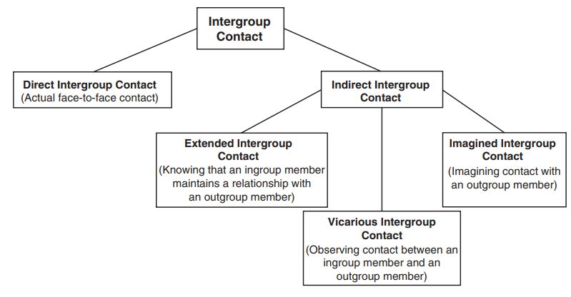
* Decategorization vs. recategorization
* Impacts of negative encounters?
* Research focuses mainly on the majority group perspective
* Sedative effect of oup contact
* contact interventions (both direct and indirect) are an effective means to reduce prejudice and, thus, intergroup tensions

Example

* coexistence vs. confrontational models (can shift from one to the other)
* face-to-face programs between Israelis and Palestinians
* study in Rwanda aiming at testing the influence of mass media (here radio) on prejudice, norms, and intergroup behavior
* New Dawn radio show that display interactions between tribal groups
* Results of the analyses of these data indicated that participants who listened to the reconciliation soap opera displayed more cooperative intergroup behavior, compared with participants in a control condition listening to a soap opera on health issues

**A large-scale test of the link between intergroup contact and support for social change**

* Intergroup contact can undermine support for social change toward greater equality, especially among disadvantaged group members
* intergroup contact and support for social change toward greater equality are positively associated among members of advantaged groups (ethnic majorities and cis-heterosexuals), but negatively associated among disadvantaged groups (ethnic minorities and sexual and gender minorities)
* greater perceptions of intergroup harmony can undermine people’s willingness to demand and advocate for greater equality and social justice
* forms, content, and nature that contact can take are as varied as are efforts to achieve social change
* consistent support for the preregistered hypotheses that the correlation between contact and support for social change is positive among ethnic majority group members and cis-heterosexuals and negative among ethnic minority group members and LGBTIQ+ individuals
* largest positive correlation between contact and social change among ethnic majorities
* ‘working in solidarity’ as the measure of support for social change
* Disadvantaged groups who reported fewer negative contact experiences reported less support for social change
* Positive contact was positively related to working in solidarity but negatively related to other measures of support for social change
* Design cannot support causal conclusions
* Among both advantaged and disadvantaged groups, contact predicted greater willingness to work in solidarity to achieve greater social equality

**Haidt: The Moral Foundations of Politics**

* People have moral foundations beyond narrow self-interest
* The brain is like a book, the first draft of which is written during fetal development
* We need innate knowledge
* Attachment theory
* Political parties and interest groups strive to make their concerns become triggers of your moral modules
* Selfish genes can give rise to generous creatures
* Theory of reciprocal altruism
* Human life is a series of opportunities for mutually beneficial cooperation
* Humans are not the only animals that are really tribal
* Warfare is a constant fact of human life
* Love of loyal teammates and corresponding hatred of traitors
* Urge to respect hierarchical relationships
* Human authorities take on responsibility for maintaining order and justice
* Ethic of autonomy
* Omnivores have 2 competing motives: an attraction to new things (neophilia) and a fear of new things (neophobia)
* Sanctity foundation
* Care/harm foundation, Fairness/cheating foundation, Loyalty/betrayal foundation, Authority/subversion foundation, Sanctity/degradation foundation

## Lecture 4

Can programs like One Small Step make a difference”

* intergroup contact theory
* Power equalization/equal status, shared goal, intergroup cooperation/interdependence, support of authorities, law, and custom
* Opportunity for positive interactions (casual)
* Demobilizing social change is more likely when you emphasize:
  + Similarities vs. differences (when inequality is ignored vs. addressed)
  + Liking vs. respect
* How might we evaluate programs like One Small Step?
  + Impacts for participants
  + Impacts for others who bear witness to it – think back to extended contact vicarious contact, but also descriptive norms and injunctive norms
* How can we get more people to engage in this kind of conversation?

## Lecture 5

What is morality?

* Morality can trump rationality/self-interest at many times
* ‘prescriptive judgement of justice, rights, and welfare pertaining to how people ought to relate to each other’
  + This definition centers liberal thinking
* Haidt: set of values, virtues, practices, identities, institutions, tech, and psychological mechanisms that work together to regulate selfishness and make social life possible
  + Care/harm, fairness/cheating, loyalty/betrayal, authority/subversion, sanctity/degradation
* Liberals care more about care/harm
* Liberals care more equality and conservatives care more proportionality (fairness/cheating)
* Conservatives care about ingroup loyalty/betrayal, authority/subversion, and purity/degradation
* Libertarians care about liberty more than anything else (liberty/oppression, resenting restrictions on choice and actions)
* Deciding whether something is right or wrong
  + For care/harm, they think about whether someone was hurt
  + For fairness, they think about rights denial and whether some people were treated differently than others
  + For ingroup loyalty, who was the betrayal committed by, distance from people, what to see if people put the interests of the groups above their own
  + Authority, consider rank and status, fulfilling duties, lack of respect for legitimate authority, respecting societal traditions
  + Purity, disgusting, standards of decency, unnatural or degrading, control or not control desires
* For conservatives all 5 foundations matter relatively equally
* Liberals really care about harm/care and fairness
* Ingroup loyalty is within an intergroup context (us and them), authority is within a group
* 3 ways this framework is helpful:
  + Help us understand and perhaps perspective-take others’ position
  + Others’ positions might also be grounded in moral values
  + Help us talk with each other
* How this can be dangerous:
  + Stereotyping
  + Give us tools to manipulate the other group
  + It can be used in unprincipled ways to justify immoral means and ends
* How do we use moral foundations in principled ways?
* If something is grounded in morality, it is a nonnegotiable 🡪 “demoralize” things

# Week 5

## Week 5 Reading

**Blind Spots**

* There are many reasons why we do not notice the unethical behavior of others
* We pay attention to goals for which we receive rewards and often ignore those for which we do not
* People can do terrible things without recognizing the ethical impacts of their actions
* *Motivated blindness:* people who have a vested self-interest in a situation have difficulty approaching the situation without bias, even when they view themselves as honest
* Many MLB players may have felt like it was an unfair disadvantage if they didn’t use performance enhancing drugs
* Human intuition does not sufficiently hold people and organizations accountable for such indirect unethical behavior
* People commonly fail to notice the slippery slope of others’ unethical behavior
* People too often judge the ethicality of actions based on whether harm follows, rather than on the ethicality of the choice itself
* We blame people too harshly for making sensible decisions with unlucky outcomes
* There are often conflicts of interest and deliberate obfuscations that are used to perpetuate unethical behavior that is beneficial to certain parties

**Sexual harassment in academia**

* Sexual harassment is prevalent both in society and in academia
  + It has staggering psychological and physical costs
* Universities have thus far been ineffective in stopping sexual harassment
* **Ethical fading:** inability to see the ethics of one’s decisions, so then ethics are not considered in the decision-making process
* **Bounded ethicality:** systematic and predictable ways in which individuals engage in unethical behavior without their awareness
* Sexual harassment is a violation of care, fairness, loyalty, authority, and purity
* Organizational climates have a significant influence on employee behavior
* Power makes individuals less inhibited and more goal directed
* Informal processes are often more powerful than formal systems in influencing unethical behavior
* 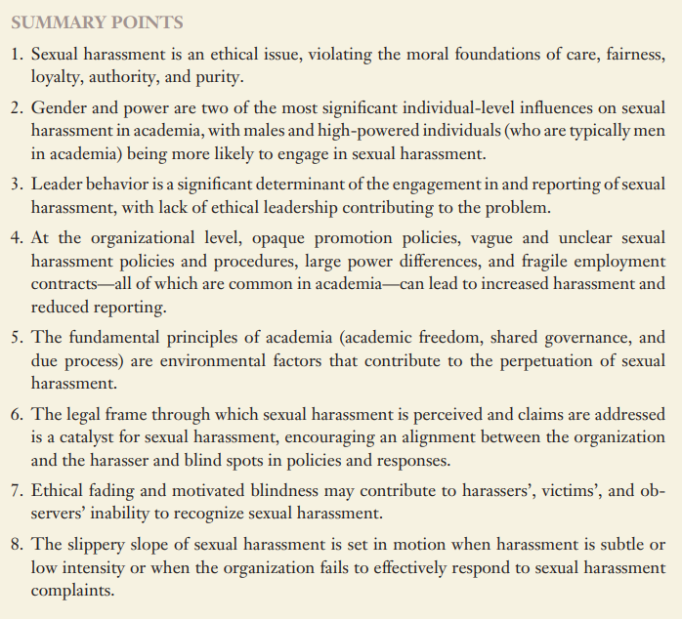

**Wisdom of the Crowds Module 5 & 6**

* 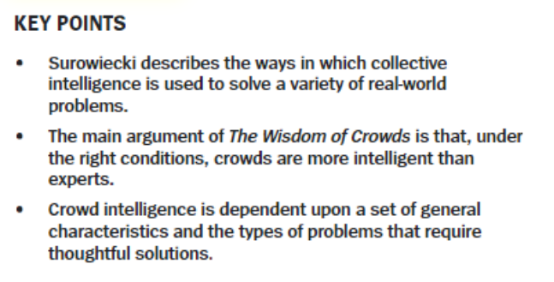
* 3 main types of problems that lend themselves well to collective wisdom solutions:
  + Cognition problems - have a definitive solution
  + Cooperation problems - require unique individuals to put aside their self-interest
  + Coordination problems – require groups of strangers to work together
* Intelligence can’t replicate cognitive diversity
* How to not be a “foolish crowd”
  + Decentralization
  + Cognitive diversity (differences in training, education, personality, or mental thought processes)
  + Independence of thought
  + Aggregation
* 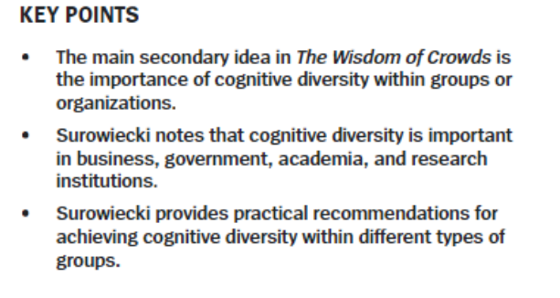
* **Cognitive diversity** is differences in perspective or information processing styles (not predicted by factors such as gender, ethnicity, or age)
* Even if you know less you can still contribute if what you add is different
* Factors that dumb down a group:
  + Skewing information
  + Groupthink
  + Herding
  + 2 behavioral traps: mimicking and heard behaviors

**How Diversity Makes Us Smarter**

* Social diversity in a group can cause discomfort, rougher interactions, a lack of trust, greater perceived interpersonal conflict, lower communication, less cohesion, more concern and disrespect
* Diversity encourages the search for novel information and perspectives, leading to better-decision and problem-solving
* Female representation in top management leads to an increase of $42 million in firm value
* When a Black person presented a dissenting perspective to a group of white people, the perspective was perceived as more novel and led to broader thinking and consideration of alternatives than when a white person introduced that same dissenting perspective. The lesson: when we hear dissent from someone who is different from us, it provokes more thought than when it comes from someone who looks like us.
* Diversity jolts us into cognitive action in ways that homogeneity does not
* Papers written by diverse groups receive more citations and have higher impact factors than papers written by people from the same ethnic group
* When groups are diverse we assume we have to work towards better outcomes 🡪 it promotes hard work and creativity

## 9/20

* Moral foundations can be misused to exploit people’s positions, moralize policy issues, and can often be ignored
* There are often conflicts between what we think we should do and what we actually want to do
* Prediction (**forecasting error**), decision time (**ethical fading**), recollection (**cognitive dissonance**)
* **Future lock-ins:** people are more likely to choose what they should do if they are thinking about the future rather than the present, so ask about a decision (with long term benefits and short-term costs) in the context of the future (so they can think about their “should” self)

*Why do we ignore institutional corruption?*

* Motivated blindness, obfuscation and the encouragement of reasonable doubt, and expressing shifting views of the facts
* **Motivated blindness**: determine our preferences based on self or group interests and then justify these preferences, often by denying or avoiding certain information
* Search for a smoking gun
  + Demanding causal evidence often puts researchers in a bind, where they cannot assign different study participants to different conditions

## 9/22

* Error cancels as long as:
  + Estimates bracket the truth
    - Diversity of viewpoints
  + Estimates are independent and voiced
    - No social pressure, no herding
  + Estimates are aggregated in an unbiased way
    - Everyone’s voice matters
  + Estimates are based on local knowledge
    - Diversity of experiences are leveraged
* Error of the group is always less than or equal to the error of the average member
* Betting markets were not independent and not based on individual, local knowledge
* If you need expert opinions, take the average of independent expert opinions
  + Second opinions matter
* Diverse perspectives are necessary to bracket the truth
* **Diversity Prediction Theorem** 
  + If I have more accurate individuals, I should get a more accurate group
  + If I have a more diverse group, I should get a more accurate group
  + *Crowd’s error = average error – diversity*
* We are talking about cognitive diversity, not socio-demographic diversity
* We assume that people have different perspectives by virtue of being in different groups, which is not always true
  + When using this theorem, we need to make sure that socio-demographic diversity reflects cognitive diversity
* Instrumental vs. moral arguments for socio-demographic diversity

# Week 8

## Readings

**The Political Brain Ch. 1 & 6**

* What determines elections are voter’s states of mind
* Networks of associations are important
* Specific narrative and crafting of an ad makes a difference
* Draw on existing associative links
* For Republicans, the road to victory is paved with emotional intentions
* Reason is a slave to emotion, even though most of us have an irrational emotional commitment to rationality

Writing an emotional constitution

* Capitalize on partisan feelings of those who tend to identify with the candidate’s party
* Need a narrative of what it means to be a Democrat or Republican
* Compelling political narrative should contain:
  + 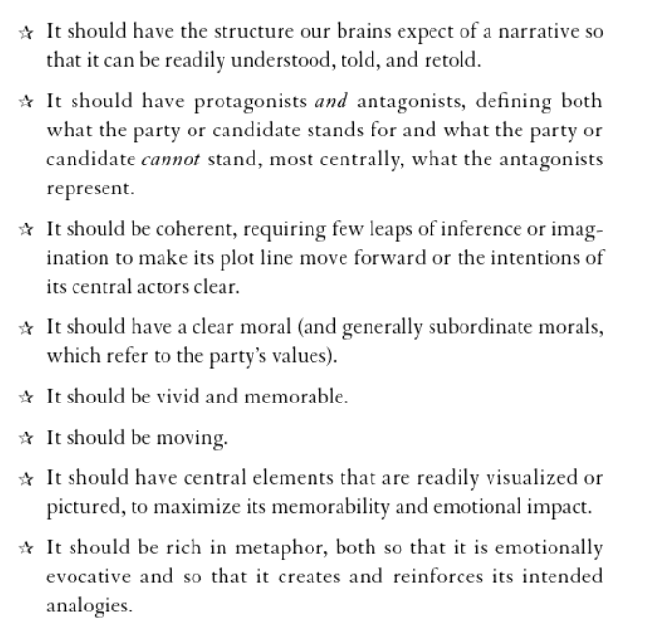
  + 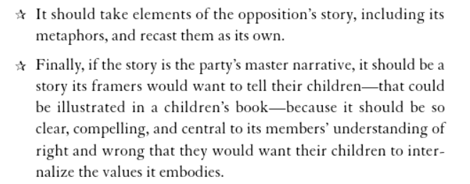
* A very American story is the relationship between personal achievement and the welfare of the community
* Ideologies are hierarchically organized, with principles at the highest level and attitudes towards policies at the lowest
* Master narrative is the emotional constitution of a party
  + An ideology stands for and against something
* A good story is defined as much by what it neglects to mention, as well as what it mentions
* There can be an intrusion of a covert political agenda
* Master narrative should alienate part of the electorate, because they weren’t going to turn anyways
* Conservatism has stood on the wrong side of virtually every effort to expand freedom in the last century
* Politics is about branding

**Shadow Cues with Deep Effects: Trait Judgments From Faces and Voting Decisions**

* impact of rapid automatic processes in political decision making
* individuals assess candidate competence on the basis of facial appearance and that this can predict the outcomes of both U.S. congressional and gubernatorial elections
* how people make decisions is different from how they should make decisions
* Faces are a rich source of social information and despite the maxim “don’t judge a book by its cover,” many people believe that they can judge the character of others from their faces
* linear relationship between the margin of victory and the difference in competence between the candidates
* competence judgments from faces are highly predictive of election outcomes

**Status threat, not economic hardship, explains the 2016 presidential vote**

* 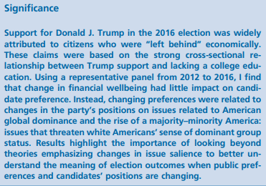
* A nationally representative panel survey was used to evaluate two central hypotheses. First, does being left behind with respect to personal financial wellbeing predict change in the direction of Republican support in 2016? Second, did issue positions reflecting perceived status threat, whether racial or global, increase the likelihood of shifting toward the Republican presidential candidate in 2016?
* Party identification contributes stability to the two-party vote, and 2016 was no exception.

## 10/11 Class

* People often either knowingly vote non-rationally or don’t have the info they need to vote based on self-interest
* Moral values shape our policy preferences
* Emotion-based decisions are not necessarily irrational
  + Emotions are adaptive
  + Emotions are motivating
  + Some emotions prompt us to deliberate (anxiety and sadness)
* Affect heuristic: people use emotional reactions to make decisions
* Emotions can be swayed by irrelevant things
* 2/3 of voter’s decisions could be accounted by partisan feelings and their feelings toward the candidates
* Jerry Clore
  + Negative emotions = stop and think
  + Positive emotions = go with it
  + Anxiety 🡪 policy over party thinking and voting
    - More likely to defect to the opposite party candidates
  + Enthusiasm 🡪 party over policy voting and engagement
    - Policy issues/positions have little to no effect on voting
* Fear can work, but can also backfire
* Fear appeals should:
  + Increase the target’s perceived vulnerability
  + Suggest a clear path to prevention (response efficacy)
  + Suggest easy enactment of the prevention behavior (self-efficacy)
* Anger mobilizes (angry voters are more likely to be more politically engaged)
* Make people feel by:
  + Target their self-interest
  + Target their moral values
  + Use principles of social influence
    - Liking, reciprocity, social proof, consistency, authority, scarcity
* Ads to your base should elicit enthusiasm, ads to other party or undecided voters should promote anxiety

## 10/13 Class

* Narratives are important because they structure people’s understanding of what has occurred and why
* Voting for the rational choice is hard, values, emotions matter but implicit and explicit biases can play a role
* Conscious/unconscious, system 1/system2, explicit/implicit, reflective/automatic
  + Behavior often lives at the intersection between these 2 competing systems, but sometimes they are at odds (so you can get preference reversal, making the preferences by definition not rational)
* Most people think that voting is deliberate, but it definitely is not entirely so
* We do the deliberate thing when we have resources and motivation
* Correlation between perception of competence/intelligence/leadership and difference in proportion of votes, r=.58
* Racial and gender biases about who is competent
* Economic dissatisfaction, denial of racism, and hostile sexism were predictors of voting for Trump
* Possibilities of reverse causation or the third variable

*Status threat, not economic hardship, explains the 2016 presidential vote (Mutz)*

* Did the change in attitude predict a change in votes?
  + IVs: status threat and economic anxiety
  + DV: change in the 2-party presidential vote 🡪 did you cross ideological lines?
* Social dominance orientation (hierarchy over equality), global-related threat
  + China, Immigration
* Ideology is always the biggest and best predictor
* None of the changes in economic satisfaction change the likelihood to vote for Trump
* Trade, immigration, and social dominance orientation were predictive

# Week 9